March 3, 2026

MS. NAOMI M. TENECIO
State Auditor IV
Audit Team Leader
Commission on Audit
Regional Office No. XIII
Butuan City

Dear Auditor,

Greetings!

In connection with the delivery of the procured items under the LIKHAng Kababaihan Regional Screening on March 6, 2026 at DMW Regional Office XIII Training Hall, Butuan City/ PO No.: 2026-02-0013, on, March 6, 2026, may we respectfully invite your good office or your dully to witness the inspection and acceptance of the said procurement.

We look forward to your usual support and cooperation.

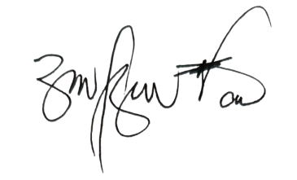
Very truly yours,

RITCHEL M. BUTAO
Regional Director

